**Guide: The title of a task will be in bold,** *and the code for how to do the task is in italic*

1. **How to create and delete a database:** 
   1. *CREATE DATABASE test;*
   2. *DROP DATABASE test;*
2. **Creating a database to work with:**
   1. *CREATE DATABASE Bahaa;*
3. **Create a table inside that databse:**

*CREATE TABLE customers(* # creating a table with the row title ‘customers’

*id INT NOT NULL AUTO_INCREMENT,* # The column ‘id’ which carries int value and

# can’t be empty

*first_name VARCHAR(255),* # the first name column w/ varchar is the data type

# and the maximum length of characters is (255)

*last_name VARCHAR(255),*

*email VARCHAR(255),*

*address VARCHAR(255),*

*city VARCHAR(255),*

*town/state VARCHAR(255),*

*zipcode VARCHAR(255),*

*PRIMARY KEY(id)* # the primary key is unique and we want id to be unique

*);*

1. **How to insert data into the table:**

*INSERT INTO customers(first_name, last_name, email, address, city, town, zipcode)*

*VALUES*

*(‘Bahaa’, ‘Shammary’, ‘bshammary@gmail.ie’, ’22 high st’, ‘Cork’, ‘Douglas’, ‘T9A5’),*

*(‘Derek’, ‘Williams’, ‘dwilliams@gmail.ie’, ’23 high st’, ‘Limerick’, ‘Abbeyfeale’, ‘T10A5’),*

*(‘Michael’, ‘Murph’, ‘m.murph@gmail.ie’, ’24 high st’, ‘Cork’, ‘Douglas, ‘T11A5’),*

*(‘Kathy’, ‘Morris’, ‘kathym@gmail.ie’, ’25 high st’, ‘Cork’, ‘Kinsale’, ‘T12A5’);*

*(‘Kate’, ‘Murphy’, ‘kmurph@gmail.ie’, ’26 high st’, ‘Kerry’, ‘Tralee’, ‘T13A5’);*

*(‘Johnny’, ‘Davidson’, ‘jdavidson@gmail.ie’, ’27 high st’, ‘Kilkenny’, ‘Callan’, ‘T14A5’);*

# first, we declare which column we would like to add the data into, and we declare that

# only once. then we write the corresponding values we would like inside each of those

# column

1. **How to update a record (i.e. a customer wanting to change their email address):**
   1. *UPDATE customers*

*SET email = ‘test@gmail.com’* # the change we want

*WHERE id =3;* # to which row it will affect

1. **How to delete an entire row (deleting a customer):**

*DELETE FROM customers*

*WHERE id = 5;* # here you can delete by id but you can choose other column names

1. **ALTERING A TABLE (i.e. adding a column)**
   1. *ALTER TABLE customers ADD COLUMN newColumn VARCHAR(255);*
   2. *ALTER TABLE customers ADD COLUMN age INT;* # we will need this later for select
   3. **Changing a column’s data type:**

*ALTER TABLE customers*

*MODIFY COLUMN newColumn INT(11);*  # changing column’s data type from varchar to int

1. **Deleting a column from a table:**

*ALTER TABLE customers*

*DROP COLUMN newColumn;*

1. **Selecting from a table:**

*SELECT * FROM customers;* # selecting all from the table

*SELECT first_name, last_name FROM customers;* # selecting specific columns from table

*SELECT * FROM customers WHERE first_name = ‘Bahaa’;* # selecting a specific customer

*SELECT * FROM customers ORDER BY last_name;* # sorting order of all the data by last name

*SELECT * FROM customers ORDER BY last_name DESC;* # sorting last name in desc order

*SELECT * FROM customers ORDER BY last_name ASC;* # sorting last name in ascending order

*SELECT city FROM customers;*  # getting all cities

*SELECT DISTINCT city FROM customers;* # by adding ‘DISTINCT’, we remove duplicates

1. **Selecting from a table (numbers)**
   1. *SELECT * FROM customers WHERE age < 30;*

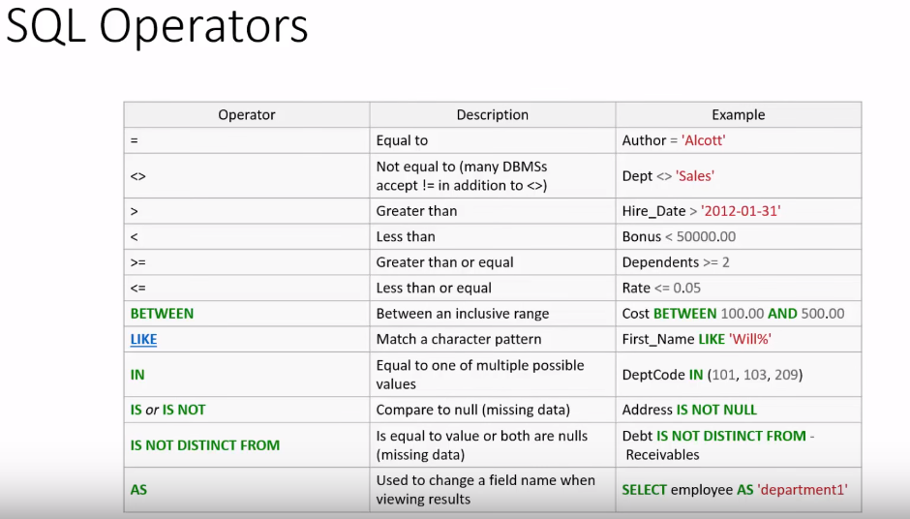

* 1. **Wanting customers age between 22 and 40 (using BETWEEN):**

*SELECT * FROM customers WHERE age BETWEEN 22 AND 40;*

* 1. **Using LIKE:**

*SELECT * FROM customers WHERE city LIKE ‘%C%’; #‘%’ means anything before and after c*

* 1. **Using NOT LIKE:**

*SELECT * FROM customers WHERE city NOT LIKE ‘%C%’; # anything that doesn’t have c*

* 1. **Using IN:**

SELECT * FROM customers WHERE town IN (‘Douglas’, ‘Kinsale’);